The Starry Night
BY ANNE SEXTON
That does not keep me from having a terrible need of—shall I say the word—religion. Then I go out at night to paint the stars.Vincent Van Gogh in a letter to his brother
The town does not exist
except where one black-haired tree slips
up like a drowned woman into the hot sky.
The town is silent. The night boils with eleven stars.
Oh starry starry night! This is how
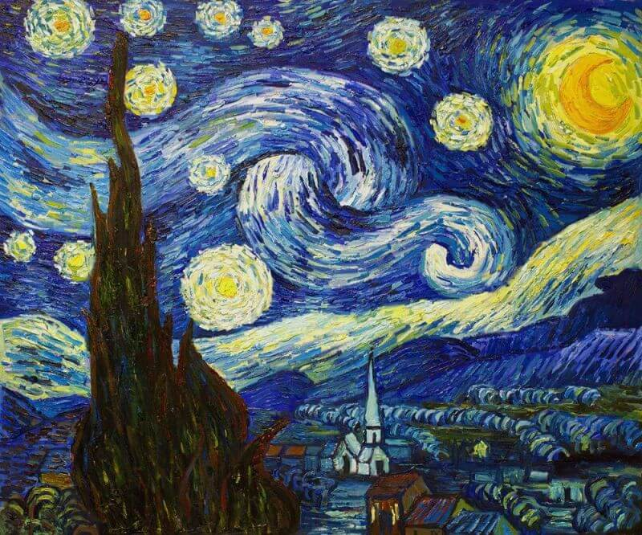
I want to die.

It moves. They are all alive.
Even the moon bulges in its orange irons
to push children, like a god, from its eye.
The old unseen serpent swallows up the stars.
Oh starry starry night! This is how
I want to die:

into that rushing beast of the night,
sucked up by that great dragon, to split
from my life with no flag,
no belly,
no cry.
Anne Sexton, “The Starry Night” from The Complete Poems of Anne Sexton (Boston: Houghton Mifflin, 1981). Copyright © 1981 by Linda Gray Sexton and Loring Conant, Jr. Reprinted with the permission of Sterling Lord Literistic, Inc.
Source: The Complete Poems of Anne Sexton (Houghton Mifflin Harcourt, 1981)

Vincent Van Gogh, 1889, Metropolitan Museum of Art, New York.

Musée des Beaux Arts (1940)
About suffering they were never wrong,
The Old Masters: how well they understood
Its human position; how it takes place
While someone else is eating or opening a window or just
walking dully along;
How, when the aged are reverently, passionately waiting
For the miraculous birth, there always must be
Children who did not specially want it to happen, skating
On a pond at the edge of the wood:
They never forgot
That even the dreadful martyrdom must run its course
Anyhow in a corner, some untidy spot
Where the dogs go on with their doggy
life and the torturer's horse
Scratches its innocent behind on a tree.
In Breughel's Icarus, for instance: how everything turns away
Quite leisurely from the disaster; the ploughman may
Have heard the splash, the forsaken cry,
But for him it was not an important failure; the sun shone
As it had to on the white legs disappearing into the green
Water; and the expensive delicate ship that must have seen
Something amazing, a boy falling out of the sky,
had somewhere to get to and sailed calmly on.

https://www.poetrybyheart.org.uk/poems/mus-e-des-beaux-arts

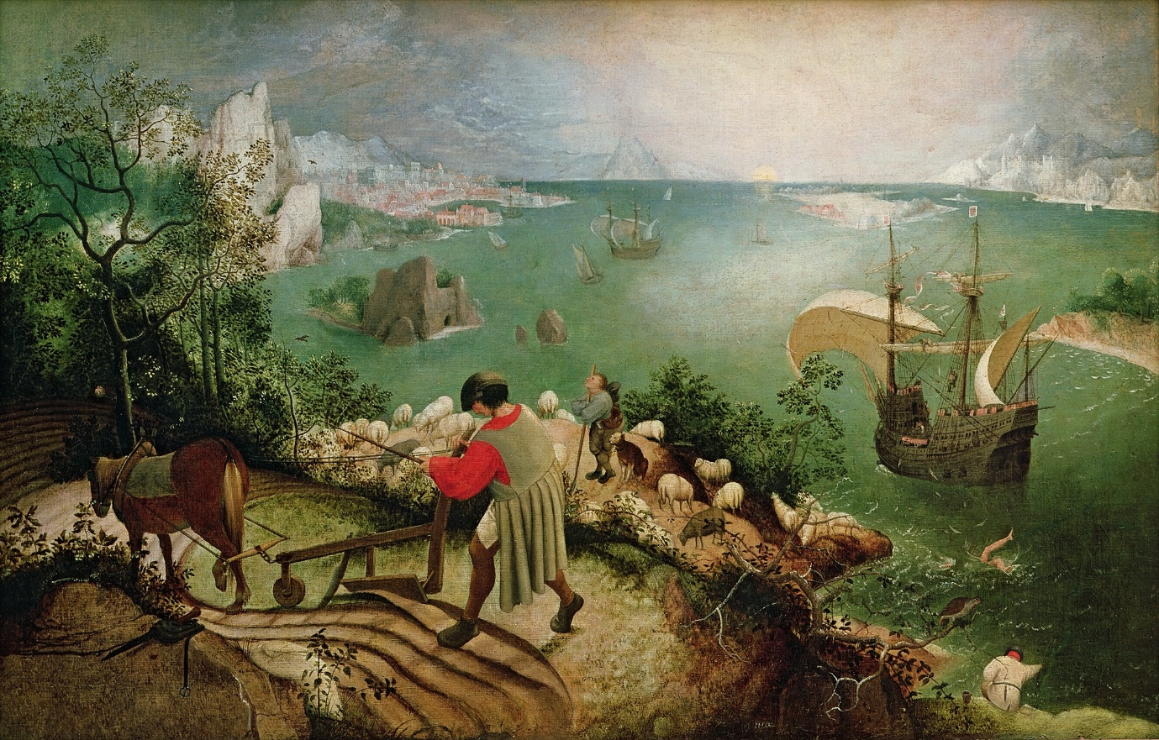
Landscape with the Fall of Icarus, Pieter Breugel the Elder, 1560

Landscape with the Fall of Icarus

William Carlos Williams
1883 –1963
According to Brueghel
when Icarus fell
it was spring
a farmer was ploughing
his field
the whole pageantry
of the year was
awake tingling
near
the edge of the sea
concerned
with itself
sweating in the sun
that melted
the wings' wax
unsignificantly
off the coast
there was
a splash quite unnoticed
this was
Icarus drowning
https://poets.org/poem/landscape-fall-icarus

Paolo Uccello, St. George and the Dragon
Oil on canvas. National Gallery, London.
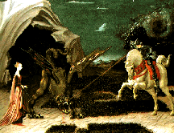
Not my Best Side
U. A. Fanthorpe
I
Not my best side, I'm afraid.
The artist didn't give me a chance to
Pose properly, and as you can see,
Poor chap, he had this obsession with
Triangles, so he left off two of my
Feet. I didn't comment at the time
(What, after all, are two feet
To a monster?) but afterwards
I was sorry for the bad publicity.
Why, I said to myself, should my conqueror
Be so ostentatiously beardless, and ride
A horse with a deformed neck and square hoofs?
Why should my victim be so
Unattractive as to be inedible,
And why should she have me literally
On a string? I don't mind dying
Ritually, since I always rise again,
But I should have liked a little more blood
To show they were taking me seriously.
II
It's hard for a girl to be sure if
She wants to be rescued. I mean, I quite
Took to the dragon. It's nice to be
Liked, if you know what I mean. He was
So nicely physical, with his claws
And lovely green skin, and that sexy tail,
And the way he looked at me,
He made me feel he was all ready to
Eat me. And any girl enjoys that.
So when this boy turned up, wearing machinery,
On a really dangerous horse, to be honest
I didn't much fancy him. I mean,
What was he like underneath the hardware?
He might have acne, blackheads or even
Bad breath for all I could tell, but the dragon--
Well, you could see all his equipment
At a glance. Still, what could I do?
The dragon got himself beaten by the boy,
And a girl's got to think of her future.
III
I have diplomas in Dragon
Management and Virgin Reclamation.
My horse is the latest model, with
Automatic transmission and built-in
Obsolescence. My spear is custom-built,
And my prototype armour
Still on the secret list. You can't
Do better than me at the moment.
I'm qualified and equipped to the
Eyebrow. So why be difficult?
Don't you want to be killed and/or rescued
In the most contemporary way? Don't
You want to carry out the roles
That sociology and myth have designed for you?
Don't you realize that, by being choosy,
You are endangering job prospects
In the spear- and horse-building industries?
What, in any case, does it matter what
You want? You're in my way.
http://english.emory.edu/classes/paintings&poems/uccello.html

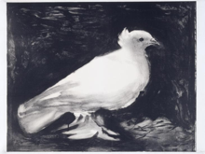
The Dove Called Peace

The attempt is realism in contrast.
White feathers protrude before charcoal,
dark as the hands in the shadows
we cannot see.

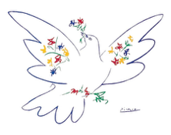
Then contracts are cast betrayals.
Splashed symbols of colour
upon wings outstretched,
that fly away from us.

The final form is sold.
A canvas commodity
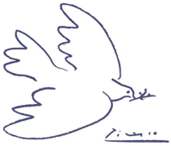
now a tired reproduction.
Oil upon water is unable to mix.

At what point did you lose your way?
You are no more peace
than the knee upon the neck,
the noose from the bough,
the drone upon the market,
the mortar upon the child.

You are but lines and shade.
A simple form upon the complex
page of life evolving, yet still
holding out the branch.

Self 2022-1914
I reflect my mind through ink lines
on a canvas soul window.
How many strokes will score the stains
and trace the face of unity.

I am the seer of mankind.
Innocence to experience, peace to war,
split sheets, marriage sold, mortar to dust.
We are but sordid art.

For I am only a boy, drawing on a sheet,
nib on paper, life-container.
But form has shifted. My muse has satin
slipped upon pillow bare, raw on its slab.

We age backwards, die and fight,
live and love, breathe and born.
Look into my face, look into you.
I am the seer of shells.

Mark the empty bells from Mariupol to Ypres.
This augur of betrayal dents
my face, like the holes in flesh.
Youth formed, produce in a butcher’s shop.

Look into my deep circles of space,
black holes reflecting back your black self.

The following poem, written in free verse, is influenced by Sir Stanley Spencer’s life, his marriage to Patricia Preece and the painting Double Nude Portrait: The Artist and his Second Wife (The Leg of Mutton Nude), 1937.

Muse
The warm hue of the fire
does not match the heat
of your cadmium gaze.
Coal crimson scorches skin
until I am pending

consummation with spread
flesh, leg to leg in raw realism.
I reflect light, blending sienna
and white, like Renoir’s Lise.
I bare all as an offering.

We are not a balanced
composition; the background
voyeur struggles for space,
upon a burdened longing.
I am an inedible fruit.

So you will hunger
as my dermis, fibre and sinew
reveals our symmetry.
Was I female before you added
more umber and ripped my soul
to perfection?

My tenderised meat
is a sagged vision; a parody
of classicism. Now I lie
on the slab like bacon,
a Freudian finale, raw and open.

Look again, you distorted critic.
I am Arcadia naked,
served to your impulses,
on a platter from which
you will not eat.

Emptiness and Sentinels

How have I found myself here?
Standing and stroking chin hairs,
aiming to look intellectual, but failing,
in mismatched tartan and flowers.

The oak-lined floors are polished,
perpendicular echoes of trods
and the odd busted plinth of a toff.
There lies a bench, on which the unfit rest.

The nannied children want to run
and knock the blocks off
the stuffy-nosed and bare-arsed statues.
Whose history is on display for us?

At every juncture, a hat-booted sentinel
is mindreading the masses.
His pride is striking before thinking.

And so, before I commit thoughtcrime, I escape
to the Pre-Raphaelite room of redheads and posies.
At least, in there, fantasy flies,
rather than captured in the Classics.

At once they welcome me. Flowing gowns,
draped on dappled horses. Blurred edges,
fluffed crowns, fair and limp
arms summoning lustful knights.

A woman dissolves in a wooden boat,
lurching forwards like a Valkyrja,
coroneted by flowers, that traipse
like fingertips on water.

Ophelia appears submerged, palms up
in submission to her garlands and willow.
They encircle, knowing her wet satins
will engorge her and never let her live.

I regress, consumed in a child’s pre-sleep.
Dream-casting Cleopatra and Camelot,
toga wrapped, rerunning the narrative,
of being lusted and lusting.

But the truth still stands.
Love is pain. Love is distant
and I am more Ophelia than Guinevere.
Strolling halls alone, still willing and wanting,
but finding only emptiness and sentinels.

